LAB 10 DeadLock

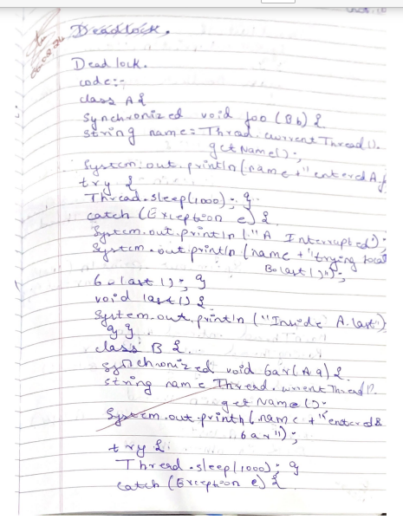

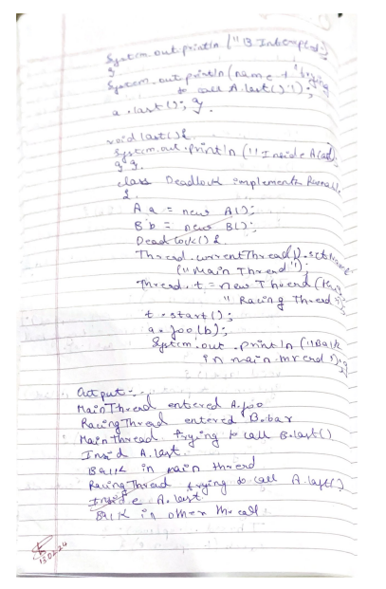

Code:-

class A {  
synchronized void foo(B b) {  
String name = Thread.currentThread().getName();  
System.out.println(name+" entered A.foo");  
try {  
Thread.sleep(1000);  
}  
catch(Exception e) {  
System.out.println("A Interrupted");  
}  
System.out.println(name+" trying to call B.last()");  
b.last();  
}  
void last() {  
System.out.println("Inside A.last");  
}  
}  
  
class B {  
synchronized void bar(A a) {  
String name = Thread.currentThread().getName();  
System.out.println(name + " entered B.bar");  
try {  
Thread.sleep(1000);  
}  
catch(Exception e) {  
System.out.println("B Interrupted");  
}  
System.out.println(name + " trying to call A.last()");  
a.last();  
}  
  
void last() {  
System.out.println("Inside A.last");  
}  
}  
class Deadlock implements Runnable  
{  
A a = new A();  
B b = new B();  
Deadlock() {  
Thread.currentThread().setName("MainThread");  
Thread t = new Thread(this,"RacingThread");  
t.start();  
a.foo(b); // get lock on a in this thread.  
System.out.println("Back in main thread");  
}  
  
public void run() {  
b.bar(a); // get lock on b in other thread  
System.out.println("Back in other thread");  
}  
public static void main(String args[]) {  
new Deadlock();  
}  
}

output:-

